**Electrostatics**

It is the branch of science that deals with the study of forces, fields, and potentials arising from the static (rest).

**Electric Charge:** In 600 B.C., the Greek Philosopher Thales observed that amber, when rubbed with wool, acquires the property of attracting objects such as small bits of paper, dry leaves, dust particles, etc. This kind of electricity developed on objects, when they are rubbed with each other, is called frictional electricity.

The American scientist Benjamin Franklin introduced the concept of positive and negative charges in order to distinguish the two kinds of charges developed on different objects when they are rubbed with each other. Charge is the property associated with matter due to which it produces and experiences electrical and magnetic effects.

**Types**

There exist 2 types of charges in nature

1. Positive charge

2. Negative charge

Charges with same electrical sign repel each other and charges with opposite sign attract each other.

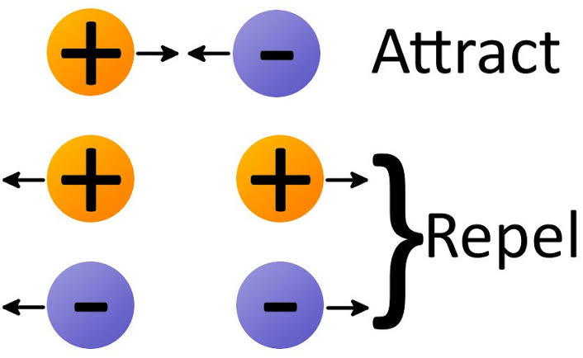

**Unit and dimensional formula**

S.I unit of charges is Coulomb (C)

C.G.S unit of charge is e.s.u. 1 C = 3 x 10-9 esu

**Point charge**

Whose spatial size is negligible as compared to other distances.

**Properties**

**1. Charge is a scalar quantity:** Charge can be added or subtracted algebraically.

**2. Charge is transferable:** If an uncharged body is, uncharged body becomes charged due to the transfer of charge from one body to the other.

**3. Charge is always associated with mass:** Charge cannot exist without mass though mass can exist without charge.

**4. Charge is conserved:** Charge can neither be created nor be destroyed but can be transferred from one body to another.

**Quantization of charge:** When physical quantities can any value rather than any discrete values rather than any value, the quantity is said to be quantized. The smallest charges that can exist in nature is an electron. If the charge of an electron (-1.6 x 10-19 C) is taken as elementary unit i.e. quanta of charge on anybody will be some integral multiple of e i.e., Q = ±**ne** with **n**= 0, 1, 2, 3…

Charge on a body can never be 0.5 **e**, ±17.5**e** or± 10-5 **e** etc.

**COMPARISION OF CHARGE AND MASS**

|  |  |
| --- | --- |
| **Charge** | **Mass** |
| Electric charge can be positive negative or zero | Mass of a body is positive quantity |
| Charge carried by a body doesn’t depend upon the velocity of the body | Mass of a body increases with its velocity  IMG-20190412-WA0003  Where c is the velocity of light in vaccum, m is the mass and mₒ is the rest mass of the body. |
| Charge is quantized. | The quantization of mass is yet to be established. |
| Electrical charge is always conserved | Mass is not conserved as it can be changed into energy and vice-versa. |

**METHODS OF CHARGING**

**1: By Friction:** In friction when two bodies are rubbed together electrons are transferred from one body to other. As a result of this one body become positively charged and other become negatively charged but they cannot move. For this reason they are called static electricity.

**2: Charging by induction:** the process by which a neutral conductor is made electrically charged when placed near a charged object is known as charging by induction.

**3: Charging by conduction:** take two conductors, one charged and other uncharged. Bring the conductor in contact with each other. The charge (whether negative or positive) under its own repulsion will spread over both the conductors. Thus the conductor will be charged with the same sign. This is called as charging by conduction.

**Coulomb's law:** According to this law, the force of attraction or repulsion between the 2 charges at rest is directly proportional to the product of the 2 charges and inversely proportional to the square of distance between them.

q1 rq2

Let us consider two charges q1 and q2 separated by a small distance “r” apart. Let F be the force between them, According to Coulombs law, if q1 and q2 be the two charges at rest and ' r ' be the distance between them then.

F ∝ q1 x q2 --------- (1)

Also,

Or, F ∝ 1/r2 ---------------- (2)

Combine equation 1 and 2 we have:

F ∝ $\frac{q_{{1 X}^{q_{2}}}}{r^{2}}$

F = $k\frac{q_{{1 X}^{q_{2}}}}{r^{2}}$

Or;

F = $\frac{1}{4πɛo}\frac{q_{{1 X}^{q_{2}}}}{r^{2}}$

Where k is called as Coulomb’s constant or electrostatic force constant (Coulomb’s constant) depends upon the nature of the medium and system of units. In S.I units K= $\frac{1}{4πɛₒ}$ = 9x109 Nm2/C2, where ɛₒ (epsilon not) is called permittivity of free space or vaccum .Its value is 8.854x 10-12 F/m.

**Vector form of Coulomb's Law:** If be the force on charge due to charge and be the unit vector from to then Coulomb's law can be written as,

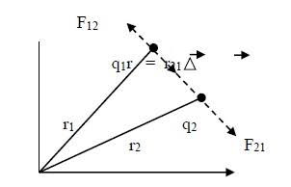

If F12 be the force on charge due to chargeq1 and r1 be the unit vector from to then we can write Coulomb's law as

F 12= r21

Also we know that;

F 21= r12

Thus the forces exerted by the two charges on each other are equal and opposite.

Hence Coulomb's law is in accordance with Newton Third Law of Motion which states that action and reaction are equal and opposite.

Thus features of Coulomb's Law. They form action and reaction pair.

1: F is repulsive if charges are alike.

2: F is attractive if charges are unlike.

3: Electrostatic Force between two charges central in nature that is force which act along the line joining the centers of two interacting objects.

4: These forces are conservative in nature.

6: This force is stronger than gravitational forces but weaker than strong nuclear force.

7: Coulombs Force decreases when the charges are placed in a medium other than air or vacuum.

**Limitation of Coulomb's Law:**

1. Coulomb’s law is applicable in case of point charges only. It is not applicable when charged bodies are spheres etc.

2. It does not apply when charges are in motion.

3. It is valid for very small and for very large distances that is greater than nuclear distance.

**Dielectric constant or relative permittivity:** Relative permittivity is defined as the permittivity of given material relative to that of the permittivity of a vaccum. It is normally represented by ɛr .

Using the fact that the permittivity of a medium is governs the change that can be held by a medium, it can be that the formula to determine it is:

ɛ = $\frac{D}{E}$

Where:

ɛ = Permittivity of the substance in Farads/mts.

D = Electric flux density.

E = Electric field strength.

It can be seen from the definitions of permittivity that constants are related according to the following equation:

ɛr =

Where:

ɛr = Relative permittivity.

ɛs = Permittivity of the substance in Farads/mts.

ɛo = permittivity of the vaccum in Farads/mts.

Hence dielectric constant of medium is defined as the ratio of Coulomb's Force between two charges placed in vaccum with some distance to Coulomb's Force between same two charges placed a distance r apart in medium. It is also known as specific inductive capacity of the medium or relative permittivity of the medium. Dielectric constant is Dimensionless.

**Superposition principle** –

Superposition principle helps to find forces among many charges. Superposition principle states that, among many charges total force acting on a given charge are to other charges is the vector sum of the individual forces exerted on it due to all other charges.

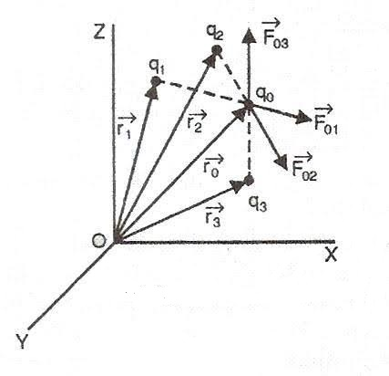

If we have n - charges then force exerted on charges will be given as;

F = F01 + F02 + F03 +…………….. Fon

Now let us find total force acting on a charge:

Force on charge q1 due to charge q0 will be;

F01 = r10 where r10 is a unit vector from q0 to q1

And similarly force on charge q2 due to charge q0 will be;

F02 = r21 where r20 is a unit vector from q0 to q2 and so on…….

According to Superposition Principle;

F = F01 + F02 +F03 +…………F0n

F= r10 + r20 + r30 +…………. rno

F ri0

**CHARGES DISTRIBUTION**

**Continuous charge distribution** – Since minimum charge that can exist is +e. Charge less than +e cannot exist. Hence, a system of closely spaced charges is said to form continuous charge distribution. It doesn’t mean that nature of charge is continuous. It simply means that distribution of charge is continuous. There are three types of charge distribution:

**1: Linear charge distribution:** When electric charge is uniformly distributed over the length, then we call it linear charge distribution. It is also called as linear charge density and is denoted by the symbol λ (Lambda) Example: charge a wire.

Mathematically linear charge density is

λ = dq/dl

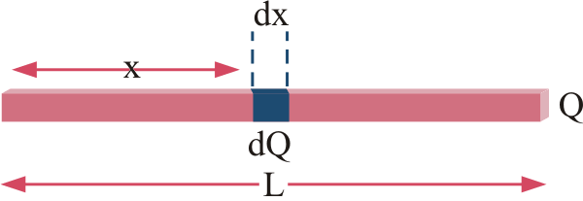

The unit of linear charge density is C/m. If we consider a wire of length ‘L’ with linear charge density λ and take an element dl on it, then small charge dq will be;

dq = λdl

So the electric field on small charge dq will be

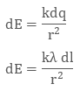

To calculate the net electric field we will integrate both sides with proper limits, that is

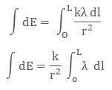

Here:

K= $\frac{1}{4πɛo}$

**2: Surface charge distribution:** When the charge is uniformly distributed over the surface, we call it surface charge density or surface charge distribution e.g. Charge on film. It is denoted by σ (sigma) symbol and its S.I. unit is C/m2.

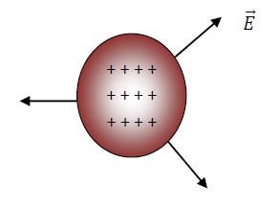

It is also defined as charge per unit area.

Mathematically surface charge density is

C:\Users\Gateway\Desktop\201769-145816722-3751-charge-4.png

Where ‘dq’ charge is the small charge element over the small surface ds. So, the small charge on the conductor will be

C:\Users\Gateway\Desktop\201769-145830675-7755-charge-5.png

The electric field due to small charge at some distance ‘r’ can be evaluated as

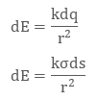

Integrating both sides we get

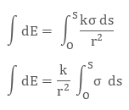

Here:

K = $\frac{1}{4πɛo}$

**3: Volume charge distribution:** When the charge is uniformly distributed over a volume of a conductor, we call it volume charge distribution e.g. charge on sphere, brick etc. It is denoted by ρ (rho). In other words charge per volume is called volume charge density and its unit is C/m3.

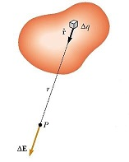

Mathematically, Volume charge density is

C:\Users\Gateway\Desktop\201769-145919970-7762-charge-8.png

Where ‘dq’ is small charge element located in small volume dv. To find the total charge we integrate dq with proper limits. The electric field due to dq will be

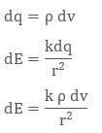

Integrating both the sides with proper limits we get;

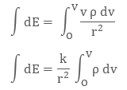

**Electric field due to a point charge**

The electric field is defined as the space around the charge such that any others charge will experience force of attraction or repulsion when placed in that space. It is a vector quantity to measure electric field we take the help of quantity electric field strength. Electric field strength at a point is the strength of electric field at that point and is defined as Force experienced by unit positive charge which one place at that point.

It is denoted by E.

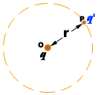

To find the electric field strength at a point in the electric field we please and infinitesimal positive charge at that point. This charge is called the test charge.

The force acting on this charge is denoted F.

The force experienced by test charge q’ will be:

F = Eq’

Also; according to coulombs law

F= Kqq’

r2

We know that:

E = F

q’

Or,

E = 1 x F

q'

Putting the value of F we get:

C:\Users\Gateway\Desktop\New folder (2)\electric_line5.gif

C:\Users\Gateway\Desktop\New folder (2)\electric_line6.gif

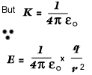

The test charge is assumed so small that it does not cause any change in initial electric field.

Electric field strength is a vector quantity which direction is same as that of force.

The SI unit of electric field strength is Newton/Coulomb.

**Effect of dielectric medium**

If there is a medium of dielectric constant ( **er**) between the source charge and the field charge, intensity at a point charge will decrease **er** times i.e.

C:\Users\Gateway\Desktop\New folder (2)\electric_line8.gif

**VECTORIAL FORM**

**C:\Users\Gateway\Desktop\New folder (2)\electric_line9 (1).gif**

**Electric lines of force or field lines**

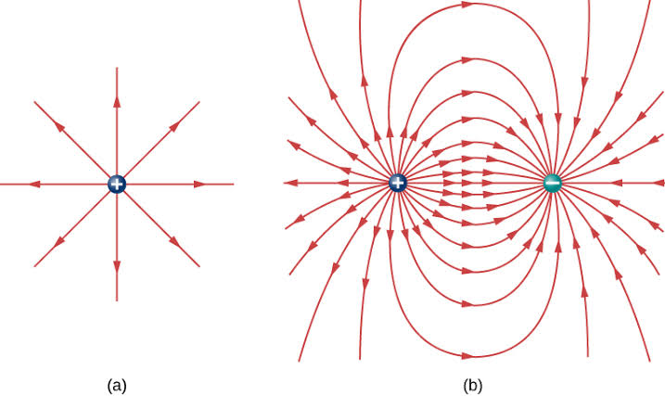

The concept of electric line of force was introduced by Michael Faraday and electric lines of force are imaginary lines that does not exist in reality and may be defined as the path followed by a unit positive charge it may be straight or curved and tangent to it at any point give the direction of electric field strength at that point.

**Properties of electric lines of force or field lines**

1. These are discontinuous curves they start from positive charge and end at negative charge but do not pass through charged body.

2. These lines can pass through the insulator.

3. Two electric lines of force cannot cross each other because if they cross then there will be two tangents at the point of intersection giving out to direction of E at one point which is not possible

4. The electric line of force are closer where the field is strong and the line of force are farther apart with the field is weak.

5. The number of electric line of force per unit area is directly proportional to the strength of an electric field

**Electric dipole**

An electric dipole is a separation of positive and negative charges.It consists of a pair of equal and opposite charges separated by a very small distance.

**Ideal dipole**

If the charge Q become larger and larger and the separation 2a become smaller and smaller then in limiting case we get an ideal dipole

**Dipole moment:** It is represented by P the magnitude of dipole moment is equal to the product of either of the charges and the distance between them

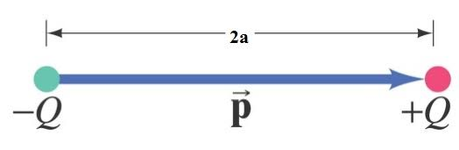

p=2aQ

It is a vector quantity the direction of p is from negative charge to positive charge

The SI unit of dipole moment is coulomb meter Cm

**Dipole field**

The dipole field is an electric field produced by an electric dipole it is defined as a space around a dipole in which the electric effect of dipole can be experienced.

**Electric intensity due to an electric dipole at a point on its axial line:**

A line passing through the positive and negative charge of electric dipole is called the axial line of electric dipole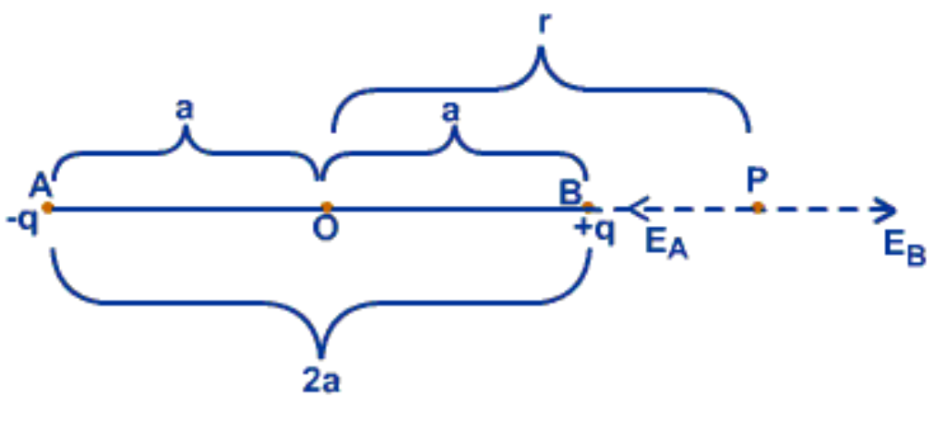

Considered an electric dipole consisting of two charges -q and +q separated by a distance to 2a as shown in the figure above. Let P be the point where the electric field intensity is to be determined.

If E is the electric field intensity then;

Electric field at P (EB) due to charge +q is given by,

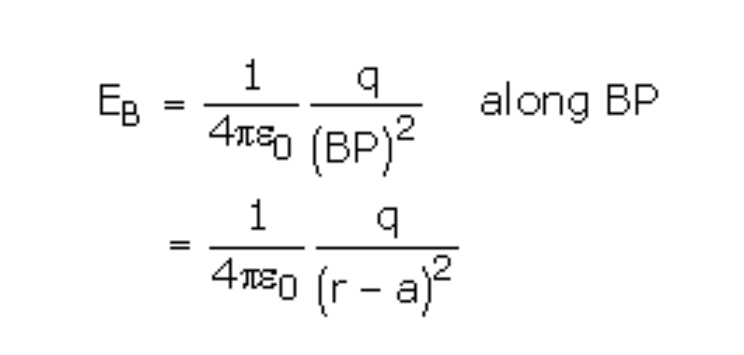

Electric field at P (EA) due to charge –q is given by,

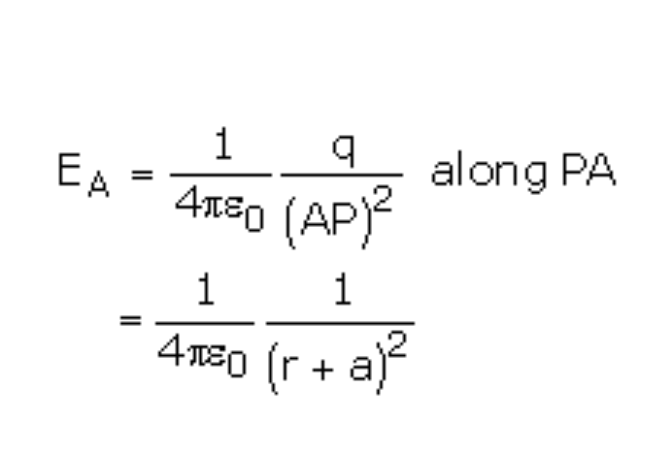

Net electric field intensity at P is given by:

EP = EB – EA

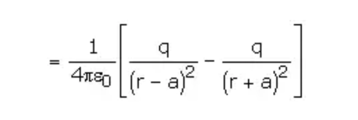

Simplifying, we get

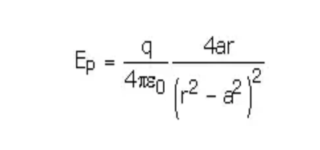

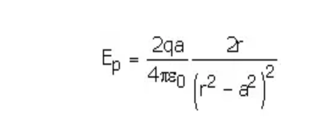

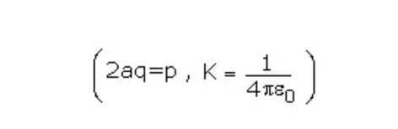

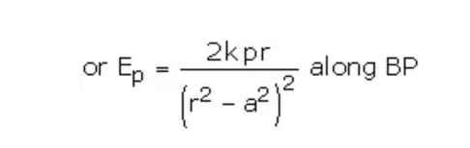

As a special case: if 2a << r we neglect 2a

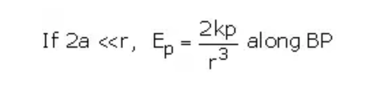

**Electric field intensity on equatorial line of dipole**

Equatorial line it is defined as line perpendicular to axial line and passes through the center of electric dipole

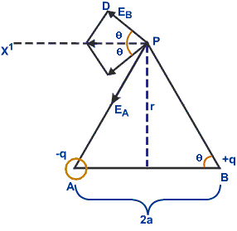

Let us take an electric dipole it consists of two point charges -q and + q separated by a very small distance 2a. We have to calculate electric field intensity at Point P on equatorial line of dipole.

Let OP= r. Join AP and BP.

Then:

Using Pythagoras theorem in right angle triangle AOP, we have

AP2 = OP2 + OA2

AP2 = (r2 + a2)

Also:

AP = (r2 + a2)1/2

Using Pythagoras theorem in right angle triangle BOP, we have

BP2 = OP2 + OB2

BP2 = (r2 + a2)

Also:

BP = (r2 + a2)1/2

Electric field intensity at P due to - q placed at Point A is given by

EA= 1 q

4πɛo (AP2)

But

AP2 = (r2 + a2)

Therefore:

EA= 1 q

4πɛo (r2 + a2)

Electric field intensity at P due to - q placed at Point A is given by

EB= 1 q

4πɛo (BP2)

But

BP2 = (r2 + a2)

Therefore:

EB= 1 q

4πɛo (r2 + a2)

The resultant intensity is the vector sum of the intensities along PA and PB.EA and EB can be resolved into vertical and horizontal components. The vertical component EA and EB cancel each other as they are equal and oppositely directed. It is the horizontal components which add up to give the resultant field

Net electric field intensity is given by

E = EA cos Ɵ + EB cos Ɵ

E = (EA + EB) cos Ɵ

As EA = EB ; therefore

E = (2EA cos Ɵ)

E = 2 q cos Ɵ

4πɛo (r2 + a2)

E = 2 q Base

4πɛo (r2 + a2) Hypotenuse

E = 2 q a

4πɛo (r2 + a2) (r2 + a2)1/2

As 2aq= p

E = p

4πɛo (r2 + a2)3/2

If 2a << r we neglect 2a therefore

**E = kp**

**r3**

Electric field intensity on axial line is twice as that of the equatorial line.

**Torque acting on a dipole placed in electric field or dipole in uniform electric field**

**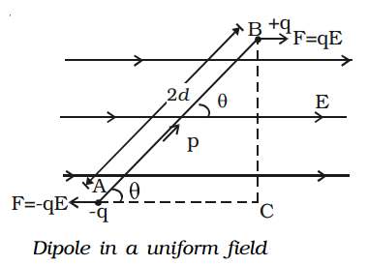**

Let us take an electric dipole it consists of two equal and opposite charge - q and + q separated by a very small distance 2d. Let the dipole is placed in uniform electric field at an angle with the direction of E

The force on + q charge F= qE along the direction of E

The force on - q charge F= qE along the direction of E

These two forces are equal, parallel and opposite and they act at different points and their form couple who torque is given by

Ʈ = F x perpendicular distance

Ʈ = qE x BC …………………………………………… (1)

In right angle triangle ABC

sin Ɵ= perp

Hyp

sin Ɵ = BC

AB

BC = sin Ɵ AB

As AB = 2d

Therefore

BC = sin Ɵ 2d ……………………………………………. (2)

Putting (2) in (1) we get

Ʈ = qE x sin Ɵ AB

Ʈ = qE x sin Ɵ 2d

As q x 2d = p

Therefore

Ʈ = p x E sin Ɵ

Here 2 conditions arises that is

When Ɵ = 0ᵒ

Ʈ = p x E sin 0ᵒ

As sin 0ᵒ = 0

Ʈ = p x E x 0

Ʈ = 0

In this case we get minimum torque

When Ɵ = 90ᵒ

Ʈ = p x E sin 90ᵒ

As sin 90ᵒ = 1

Ʈ = p x E x 1

Ʈ = p x E

In this case we get maximum torque

**Electric flux:**

Electric flux is the rate of flow of the electric field through a given area. Electric flux is proportional to the number of the electric field lines going through a virtual surface.

If the electric field is uniform, the electric flux passing through the surface of vector area S is

ΦE= E.S cos Ɵ.

Where E is the magnitude of the electric field (having units of V/m), S is the area of the surface, and Ɵ is the angle between the electric field lines and the normal (perpendicular) to S.

For a non-uniform electric field, the electric flux dΦE = E.dS (the electric field, E, multiplied by the component of area perpendicular to the field).

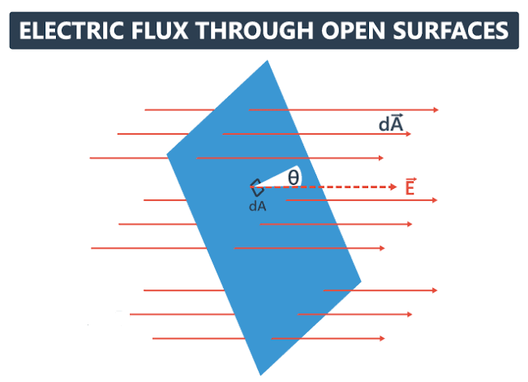

**Gauss law:**

In Physics Gauss’s Law is also known as Gauss’s flux theorem, it’s a law relating with the distribution of the electric charge to resulting electric field.

**Application Gauss law**

There are various applications of gauss law which we look at now. Just to start with, we know that there are some cases in which calculation of electric field is quite complex and involves tough integration. We use the Gauss’s law to simplify evaluation of electric field in an easy way.

Before we learn more about the applications, let us first see how we can apply the law. We must choose a Gaussian surface, such that the evaluation of the electric field becomes easy. One should make use of symmetry to make problems easier. We must also remember that it is not necessary for the Gaussian surface to coincide with the real surface. It can be inside or outside the Gaussian surface.

**Electric Field due to infinitely long straight wire:** Let us consider an infinitely long wire with linear charge density λ and length L. To calculate electric field; we assume a cylindrical Gaussian surface. As the electric field E is radial in direction, the flux through the end of the cylindrical surface will be zero.

This is because the electric field and area vector are perpendicular to each other. As the electric field is perpendicular to every point of the curved surface, we can say that its magnitude will be constant.

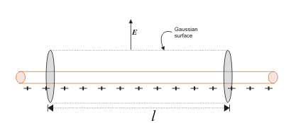

The surface area of the curved cylindrical surface is 2πrl. The electric flux through the curve is

E x 2πrl.

According to Gauss’s Law

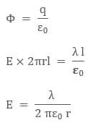

We need to remember that the direction of the electric field is radially outward if linear charge density is positive. On the other hand, it will be radially inward if the linear charge density is negative.

**Electric Field due to infinite plate sheet:** Let us consider an infinite plain sheet, with surface charge density σ and cross-sectional area A. The position of the infinite plane sheet is as below:

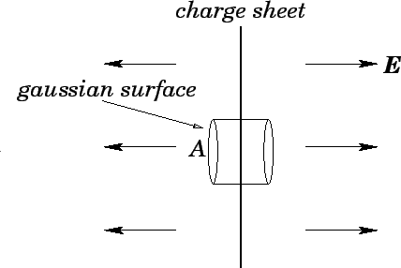

The direction of the electric field due to an infinite charge sheet is perpendicular to the plane of the sheet. Let us consider a cylindrical Gaussian surface, whose axis is normal to the plane of the sheet. We can evaluate the electric field E from Gauss’s Law as according to the law:

C:\Users\Gateway\Desktop\IMG-20190425-WA0013.jpg

From a continuous charge distribution charge q will be the charge density (σ) times the area (A). Talking about net electric flux, we will consider electric flux only from the two ends of the assumed Gaussian surface. We can attribute it to the fact that the curved surface area and an electric field are normal to each other thereby producing zero electric flux. So the net electric flux is

Φ = EA – (- EA)

Φ = 2 EA

Then, we can write

C:\Users\Gateway\Desktop\IMG-20190425-WA0014.jpg

The term A cancels out which means electric field due to a plain sheet is independent of cross sectional area A and equals to:

E = $\frac{σ}{2ɛₒ}$

**Electric Field due to Thin Spherical Shell:** Let us consider a thin spherical shell of the fish charge density σ and radius ‘R’. By observation, we can see that the shell has spherical symmetry. Therefore we can evaluate the electric field due to spherical shell in two different positions

1: Electric field outside the spherical shell

2: Electric field inside a spherical shell

Let us look at these two cases in greater detail.

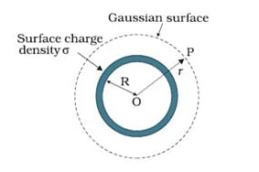

To find electric field outside a spherical shell with a key point be outside the shelf at a distance r from the centre of spherical shell by symmetry we take Gaussian spherical surface with radius r centre O. the Gaussian surface will pass through P, and experience a constant electric field E all around as all points are equally distanced “r” from the centre of the sphere. Then, According to Gauss’s Law:

C:\Users\Gateway\Desktop\IMG-20190425-WA0015.jpg

The enclosed charge inside the Gaussian surface q will be σ x 4 πR2 .The total electric flux through the Gaussian surface will be

Φ = E x 4 πR2

Then by Gauss’s Law, we can write

E x 4 πR2 = σ x

E=

Putting the value of surface charge density σ as $q/{4πR^{2}}$, we can rewrite the electric field as

E = $\frac{kq}{r^{2}}$

In vector form, the electric field is

C:\Users\Gateway\AppData\Local\Microsoft\Windows\Temporary Internet Files\Content.Word\2017623-91535607-6536-law-9 (2).png

Here ‘r’ is the radius vector, showing the direction of the electric field. What we must note here is that if the surface charge density σ is negative, the direction of the electric field will be radially inwards.

**Electric Field inside the Spherical Shell:** To evaluate electric field inside the spherical shell let's take a point p inside the spherical shell by symmetry V again take a spherical Gaussian surface passing through P, centered at O with radius r. Now according to Gauss’s law:

C:\Users\Gateway\Desktop\IMG-20190425-WA0015.jpg  
The Net electric Flux will be E x 4 πR2.

**Q. Why there is no electric field inside a spherical shell?**

Solution: the enclosed charge q will be zero, as we know that surface charge density is dispersed outside the surface, therefore there is no charge inside the spherical shell. Therefore,

**E = 0.**

****

**Electric potential:**

An electric potential is the amount of work needed to move a unit of positive charge from a reference point to a specific point inside the field without producing acceleration. Typically, the reference point is the earth or a point at infinity, although any point beyond the influence of the electric field charge can be used. It is denoted by V. Its SI unit is volt and dimensional formula is M L2 T-3 I-1.

Work = force x distance

Force is varying with distance, need integral

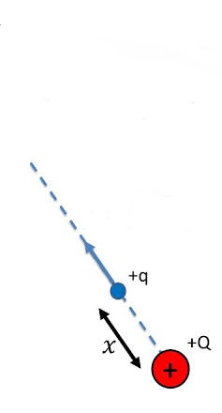

W= $\int_{∞}^{r}{Fdx}$

W= $\int_{∞}^{r}{-kQq/x²} dx$

W= $K\frac{Qq}{r}$

Potential energy U = $K\frac{Qq}{r}$

Electric potential V = $\frac{U}{q}$

V = $k\frac{Q}{r}$

**Potential difference:**

Potential difference is the work done in moving a unit of positive electric charge from one point to another.

Symbol of p.d is V.

**Electric potential due to a point charge:**

Point charges, such as electrons, are among the fundamental building blocks of matter. Furthermore, spherical charge distributions (like on a metal sphere) create external electric fields exactly like a point charge. The electric potential due to a point charge is, thus, a case we need to consider. Using calculus to find the work needed to move a test charge q from a large distance away to a distance of r  from a point charge Q , and noting the connection between work and potential W = -q∆V, it can be shown that the electric potential V of a point charge is

V= $\frac{kQ}{r}$

Where, k is a constant equal to 9 x 109 Nm2/C2The potential at infinity is chosen to be zero. Thus V for a point charge decreases with distance, whereas E for a point charge decreases with distance squared:

E= F/q

E= $\frac{KQ}{r²}$.Recall that the electric potential V is a scalar and has no direction, whereas the electric field  E is a vector. To find the voltage due to a combination of point charges, you add the individual voltages as numbers. To find the total electric field, you must add the individual fields as vectors, taking magnitude and direction into account. This is consistent with the fact that V is closely associated with energy, a scalar, whereas E is closely associated with force, a vector.

**Equipotential surface:**

Equipotential surface have the same potential. The electric force neither helps nor hinders the motion of electric charge along an Equipotential surface. Electric field lines are always perpendicular to the Equipotential surface

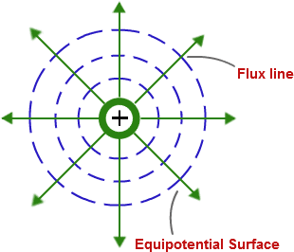

**Free and bound charge:**

In case of metal conductor, the electron in the outer most orbits are called valences.

These valence electrons are loosely bound and can be easily liberated. The liberated electrons are called free charges.

The portion of the atom (other than valences) is positively charged. The portion is called bound charge in the conductor.

**Electrostatic potential due to an electric dipole:**

An electric dipole is an arrangement of two equal and opposite charges separated by a distance 2a. The dipole moment is represented by p which is a vector quantity.

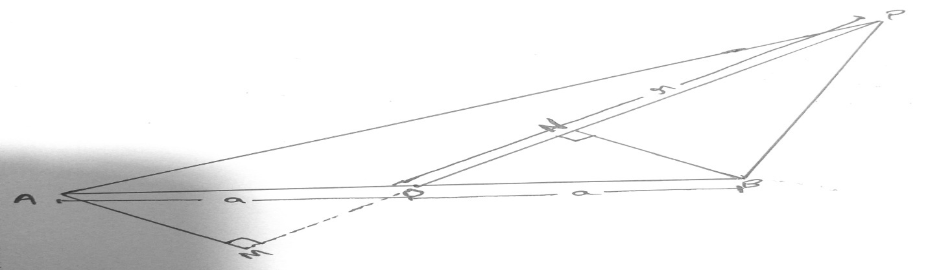

Let us consider an electric dipole such that OA =OB =a. let P be the point charge such that OP =r. let us draw AM and BN perpendicular on line OP.

In right angle triangle AMO

Cos Ɵ = Base/ hyp

Cos Ɵ = OM/OA

Cos Ɵ = OM/a

a Cos Ɵ = OM ………………………1

Also:

In right angle triangle BNO

Cos Ɵ = Base/ hyp

Cos Ɵ = ON/ OB

Cos Ɵ = ON /a

a Cos Ɵ = ON ……………………….2

As

PM ≈ PA = OP + OM = r+ a cos Ɵ

PN ≈ PB = OP – ON = r – a cos Ɵ

We know that;

V1 =

V1 =

Also;

V2 =

V2 =

Net electric potential V = V2 –V1

V =

V ={ }

V = {}

V = { }

V =

We know

P = 2aq

Therefore:

V =

If r2 >> a2 the we neglect a2 , therefore

V = $\frac{p\cos{Ɵ}}{r^{2}}$

**Dielectrics-** They are the material which cannot conduct electricity. However when an external electric field is applied, induced charges appear on the surface of dielectrics. Hence we may define dielectrics as the insulating materials which transmit electric effects without conducting. Dielectrics are of two types:

**Non –Polar Dielectrics-** These are made up of non-polar atoms/molecules. In such molecules the centre of +ve charge coincides with the centre of –ve charge. In this case each molecule has zero dipole moment in its normal state e.g. Nitrogen, Oxygen etc.

**Polar Dielectrics-** These are made up of polar atoms/molecules. In such molecules the centre of +ve charge does not coincides with the centre of – ve charge. In this case each molecule has some dipole moment poles moment in its normal state e.g. water, hydrochloric acid etc.

**Dielectric Polarization and Polarization vector-** When a non-polar dielectric is placed in an external field E0 .The centre of +ve charge (protons) of each molecule is pulled towards the –ve plate and the centre of -ve is pulled towards the +ve plate. Therefore the two centre of –ve charge and +ve charge in the molecule are separated and the molecule gets destroyed. In this case we can say that molecule is polarized and it has some dipole moment ( P ). Also the magnitude of this dipole movement becomes parallel to the external electric field E0 and direction of the dipole movement becomes parallel to the external electric field.

Thus polarization is defined as the process of alignment of the dipole moment of the dipoles in the direction of applied electric field.

**Polarization vector-** Let us consider a non-polar dielectric slab ADCD placed in an electric field E0 between two plate, All the atom of the dielectric slab ABCD are confirmly polarized in the direction of E0 and let x be the distance between them. Now dipole moment of each atom is given by

P = q . x

If N be the no. of atoms per unit volume, then dipole moment per unit volume (P) is given by

P = N P =N .q. x

Here P is polarization vector. It is defined as dipole moment per unit volume of the dielectric in the direction of electric field. The S.I unit of P is C/m2.

If we consider small volume element in the interior of the slabs, shown dotted. In this volume element charges are equal and opposite and hence they cancel each other. Hence volume charge density in this element is also zero. Clearly some net +ve charge appears on CD and some net –ve charge appears on AB. These are called polarization charge. Due to these polarization charges, electric field Ep is set up opposite to E0.

Effective electric field in the polarized dielectrics is given by E= E0 – Ep , here E is called the reduced value of electric field. Clearly the value of E depends upon the nature of dielectric slab introduced.

**Capacitor:**

Capacitor is an electronic component that stores electric charge. The capacitor is made of 2 close conductors (usually plates) that are separated by a dielectric material. The plates accumulate electric charge when connected to a power source. One plate accumulates positive charge and the other plate accumulates negative charge.

The capacitance is the amount of electric charge that is stored in the capacitor at voltage of 1 volt. The capacitance is measured in units of farad (F).

**Capacitors in series:**

**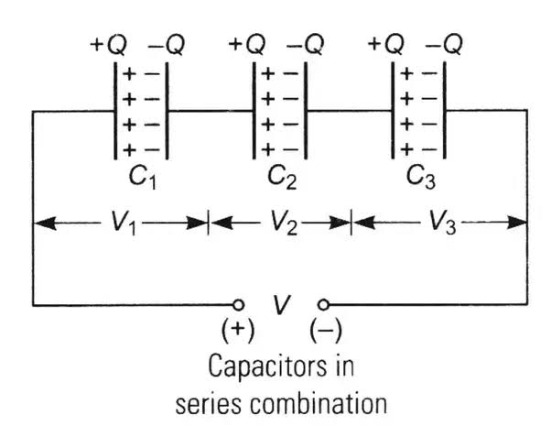**

In series, capacitor will each have the same amount of charge stored on them because the charge from the first one travels to the second one and so on. The total charge stored is the charge that was moved from the cell which equals the charge that arrived at the first capacitor, which equals the charge that arrived at the second, etc....

Let V1 is the potential difference across C1, V2 is the potential difference across C2, and so on… The voltage of the circuit is spread out amongst the capacitors such that from the diagram

Vs = V1+V2 +V3 ………………………….. 1

Also we know

Q= CV so;

V = Q/C

Therefore;

As charge on each capacitors is equal so

Vs= Q/Cs

V1 = Q/C1

V2 = Q/C2

V3 = Q/C3

Putting the values of potential differences in equation 1 we get

Q/Cs = Q/C1+Q/C2 +Q/C3

Cancelling Q we get

1/Cs = 1/C1+1/C2 +1/C3

Now for n- number of capacitors we have 1/Cs =

This is the equation of capacitors in series.

**Capacitors in parallel**

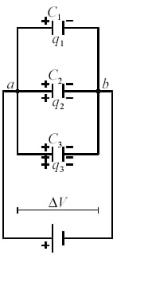

In parallel capacitors will have the same amount of potential difference but the charge stored will be different therefore total charge in parallel on above shown capacitors are

Q P =Q1 + Q 2 + Q3 ……………………………….1

We know:

Q= CV

Q p = CpV

Q 1 = C1V

Q 2 = C2V

Q 3 = C3V

Putting the above value in equation 1 we have

CpV = C1V + C2V +C3V

(Cp ) V = V (C1 + C2 + C3 )

Cancelling V on both sides we get:

Cp =C1 + C2 + C3

For n- number of capacitors we have

Cp =C1 + C2 + C3 …………………………… Cn

Cp =

This is the equation for capacitors in parallel.

**Energy stored in a capacitor**

In the case of charging of the capacitor external agents (battery) pulls electrons from positive plate of the capacitor and transfer them to the negative plate. Some work is to be done in transferring this charge; which is stored in the capacitor in the form of electrostatic energy.

Let q be the charge of the capacitor at any time, then potential of capacitor is given by V=q/C.Small amount of work done is giving additional charge dq to the capacitor is given by: dw = vdq = q/c ×dq {v=q/c}Total work done in giving charge Q to the capacitor is given by;

$\int{dw}$ = $\int_{0}^{Q}{\frac{q}{C}}dq$

W = $\frac{1}{C}\int_{0}^{Q}{qdq}$

W = $\frac{1}{C}\left({q² \atop 2}\right)$

W = $\frac{Q²}{2C}$

This work done is stored in the capacitor as electrostatic potential energy .i.e

W= U

So therefore:

U =

As Q2= C2 V2

Thus

U=

Also:

U = $\frac{(CV) V}{2}$

U= $\frac{QV}{2}$

These are the energy stored in Capacitor.

**Capacitance of parallel plate capacitor with conducting slab –**

The capacitance of parallel plate area A and plate separation ‘d’ with vaccum/air in between is given by

C0 =

Suppose +Q be the charges on the capacitor plate when a conducting slab of area A and thickness t < d is introduced between the two plates, the charge ±Q appears on the two faces of the slab due to the induction. Now the original electric field E0 exists over a distance (d-t).

Such that V=E0 (d-t)

V = (d-t) as E0=

V= (d-t) as σ =

Thus = (d-t) as V=

C = as =C0

Therefore;

C = $\frac{Cₒ}{1-t/d}$

Clearly C > Co .i.e. capacitance of parallel plate capacitor increases on introducing conducting slab.

**Capacitance of parallel plate capacitor with dielectric slab-**

The capacitance of parallel plate capacitor of plate area A and d plate separation d with vaccum/air in between is given by

C0 =

Suppose ±Q are the charges on the capacitor plates, which produce uniform electric field Eo in the space between the plates.

When a dielectric slab of thickness t<d is introduced between the plates, then an electric field inside the dielectric is given by E = E0 – Ep

Potential difference between the plates is given by

V=E0 (d-t) + E.t

But we know $\frac{Eₒ}{E}$ = k (dielectric constant)

E= $\frac{ɛₒ}{k}$

Therefore

V= E0 (d-t) + t

V = E0 (d-t + )

But E0 = =

V = (d-t + )

But V= $\frac{Q}{C}$ therefore

Q/C = $\frac{Q}{Aɛₒ}$ (d-t + $\frac{t}{k}$)

Or;

C= $\frac{Aɛₒ}{d-t+t/k}$

Or;

C= $\frac{Aɛₒ}{d-t(1-t/k}$

Clearly C > Co .i.e. on introducing dielectric slab in between the plates, the capacity of the capacitor increases.

**Van De Graff Generator-**

This was designed by Van De Graf in 1931. It is used for building up high +ve potential of order of few million volts .i.e. 105 volt.

The high +ve potential are used to accelerate charged particles .i.e. e- and ions which are used in nuclear physics.

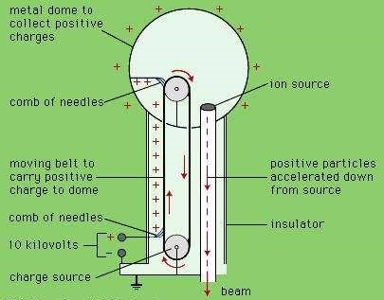

**Principle-**

Van de Graff generator is based on the principle of;

1: Action of sharp point .i.e. corona discharge.

2: It is based on the property that charge always resides on the outer surface of a hollow conductor. It always transfer to the outer surface And get distributed uniformly.

**Construction-** It consists of a large hollow spherical conductor support on two insulating pillars. A long narrow belt of some insulating material like rubber, silk or rayon is passed over the pulleys P1 and P2 [as shown in the figure]. The pulley P1 and P2 continuously C1 and C2 are called spray combine collecting comb respectively. Each of the combs C1 and C2 consist of metallic sharp point edges tips fixed on a metal plate. The +ve ion to be accelerated are produced in discharge tube D.

Working- the spray comb [C1] is given a positive potential [similar 104] with earth by high tension source. Due to discharging action positively charge , sharp points, a positively charged electric wind is set up, which spread +ve charge on the belt[corona discharge] as the belt moves and reaches the sphere, a +ve charge is induced on the sharp ends of collecting comb C2 and an equal +ve charge is induced on the further end of C2. This +ve charge shifts immediately to the outer surface of A. due to discharging action of sharp points of C2, a negatively charged electric wind is set up. This neutralizes the positive charge on the belt. The uncharged belt returns down and collects the +ve charge from C1 which in turn is collected by C2. This is repeated thus the positive charge on A goes on accumulating.

Now the capacity of spherical shell =4πɛₒR, Where R is the radius of the shell.

As V= $\frac{Q}{C}$

Therefore

V = $\frac{Q}{4πɛₒR}$

Hence the potential V of a spherical shell goes on increasing with increase in Q. To avoid leakage of charge from A to the surrounding the whole machine is kept in a steel chamber filled with nitrogen or methane at high pressure. If q is the charge on the ion to be accelerated and V is the potential difference developed across one end of the discharged tube than energy acquired by the ions= qV. The ion hit the target with this energy.